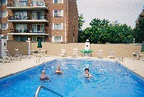

Phone: 630-898-6969
Fax: 630-898-6999

BELLES TERRES CONDOMINIUMS .
A Residential Condominium Community
Maintenance Work Request
Date of Request: / / Work Location:
Description of work/repair:

Requested Priority:
[ ] High - Must be done within 24 hours.
[ ] Medium - Within the week.
[ ] Low – When you get a chance.
For Office Use Only:

Date Reviewed: / / Priority Assigned:
Authorized By:

